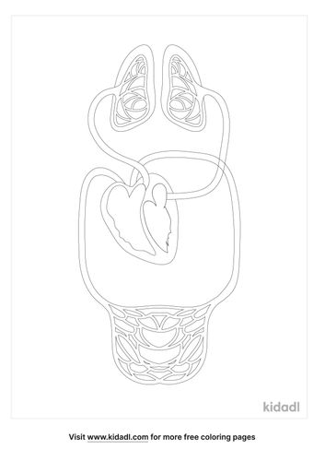

**7**.

**6**.

**5**.

**4**.

**4**.

**3**.



**8**.

**22**.

**1**.



1. Deoxygenated blood from the organs and tissues enters the right atrium.
2. Most of the blood passes directly through the right atrium into the right ventricle.
3. Pumping the blood out of the right ventricle and into the pulmonary artery. This large artery immediately forks, sending half of the blood to the left lung and half to the right lung.
4. As the blood passes through the pulmonary capillaries in the lungs, it picks up oxygen and loses carbon dioxide.
5. The oxygenated blood then enters the left and right pulmonary veins and returns to the left atrium of the heart.
6. Most of the blood passes directly through the left atrium and into the left ventricle.
7. After passing through the capillary beds in the tissues of the head, arms, trunk, and legs, the blood moves at low pressure through the veins. This deoxygenated blood returns to the heart by way of the superior and inferior venae cavae and collects in the right atrium, and the cycle repeats.